The idea of two sets being equivalent is both helpful and confusing. I have to remind myself that equivalent sets are not necessarily equal sets. And this is the major source of confusion. Sets that have the same number of members are equivalent. This means that the determinant is the cardinality of sets that we are comparing, not their content. A funny example may be that the set of meals one might have in a day {breakfast, lunch, dinner} is equivalent but not equal to the set of arms on a clock {hour, minute, second}. I want to think that logical thinking requires that math (the language of science) provide a comparison system beyond equality. And the concept is probably not very complicated if I look at it from correct perspective. If I have a set of jet fighters and a set of fighter pilots comparing the individual members of each set with each other may be useless. But knowing that the two sets are equivalent allows me to say that I have a pilot for every jet, and that is a useful statement.

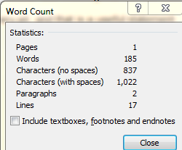

**10/23/2013**